Data preparation

We first scan the twitter API for the term ‘протест’ - Russian for protest over the period 6/30/2019 to 9/22/2019. We get 26,267 tweets.

Next we translate tweets into a new column, ‘english’ using =GOOGLETRANSLATE(text) on google docs. We then feed the english translated tweets into the Google locations parser module, and isolate only those tweets having a location. We get 2,328 tweets.

Specifically, those tweets have a breakdown of 1862 unique tweets, 2327 total tweets, and 3508 if we include country-level (more general) locations.

These are the tweet breakdowns by country, since the Russian term is not entirely specific to Russia only.

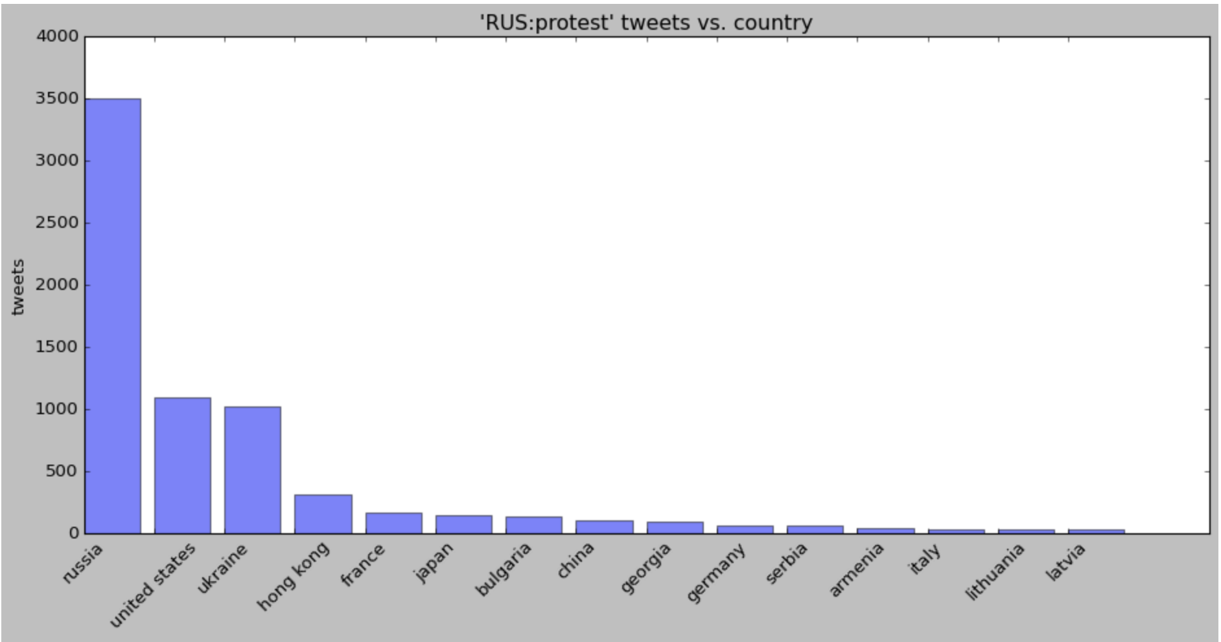

Isolation of Russian territories
We next isolate only those top (> 10 tweets) territories and places within Russia with tweet activity:

[((u'Moscow', u'GPE', 55.755826, 37.6172999), 1512),
((u'Buryatia', u'GPE', 54.83311459999999, 112.406053), 122),
((u'Siberia', u'LOC', 61.01370970000001, 99.1966559), 85),
((u'MOSCOW', u'GPE', 55.755826, 37.6172999), 50),
((u'Kremlin', u'GPE', 55.7520233, 37.6174994), 47),
((u'Moscow City Duma', u'GPE', 55.7684009, 37.6118919), 32),
((u'Yekaterinburg', u'GPE', 56.83892609999999, 60.6057025), 30),
((u'Moscow City', u'GPE', 55.755826, 37.6172999), 28),
((u'the Kuril Islands', u'LOC', 47.15439809999999, 150.9705378), 22),
((u'Sakharov Avenue', u'FAC', 55.7705001, 37.6441108), 19),
((u'Ekaterinburg', u'GPE', 56.83892609999999, 60.6057025), 16),
((u'Kurils', u'GPE', 47.15439809999999, 150.9705378), 15),
((u'Novosibirsk', u'GPE', 55.00835259999999, 82.9357327), 15),
((u'Ulan Ude', u'FAC', 51.8238785, 107.607338), 14),
((u'Leningrad', u'GPE', 59.9342802, 30.3350986), 11)]

Machine Learning Prediction setup

We tabulate those days for territory t (from the 15 above) which have protest tweet counts, and include retweets as contributing to the count as well. We then stack the tweet counts together in all 15 territories as the ‘x’ variable, with the ‘y’ variable = 1 if there was a protest the next day, and y = 0 if there was no protest the next day. I.e. our setup tries to predict, from today’s tweet traffic in all Russian territories, whether a positive protest prediction can be made for protest the following day, in a particular territory. In Moscow, there are many protests each day, whereas in the nether regions we have fewer. We hold out the last 5 or 10 days of protest activity from the training set and test those days individually for each y-variable/territory.

Results
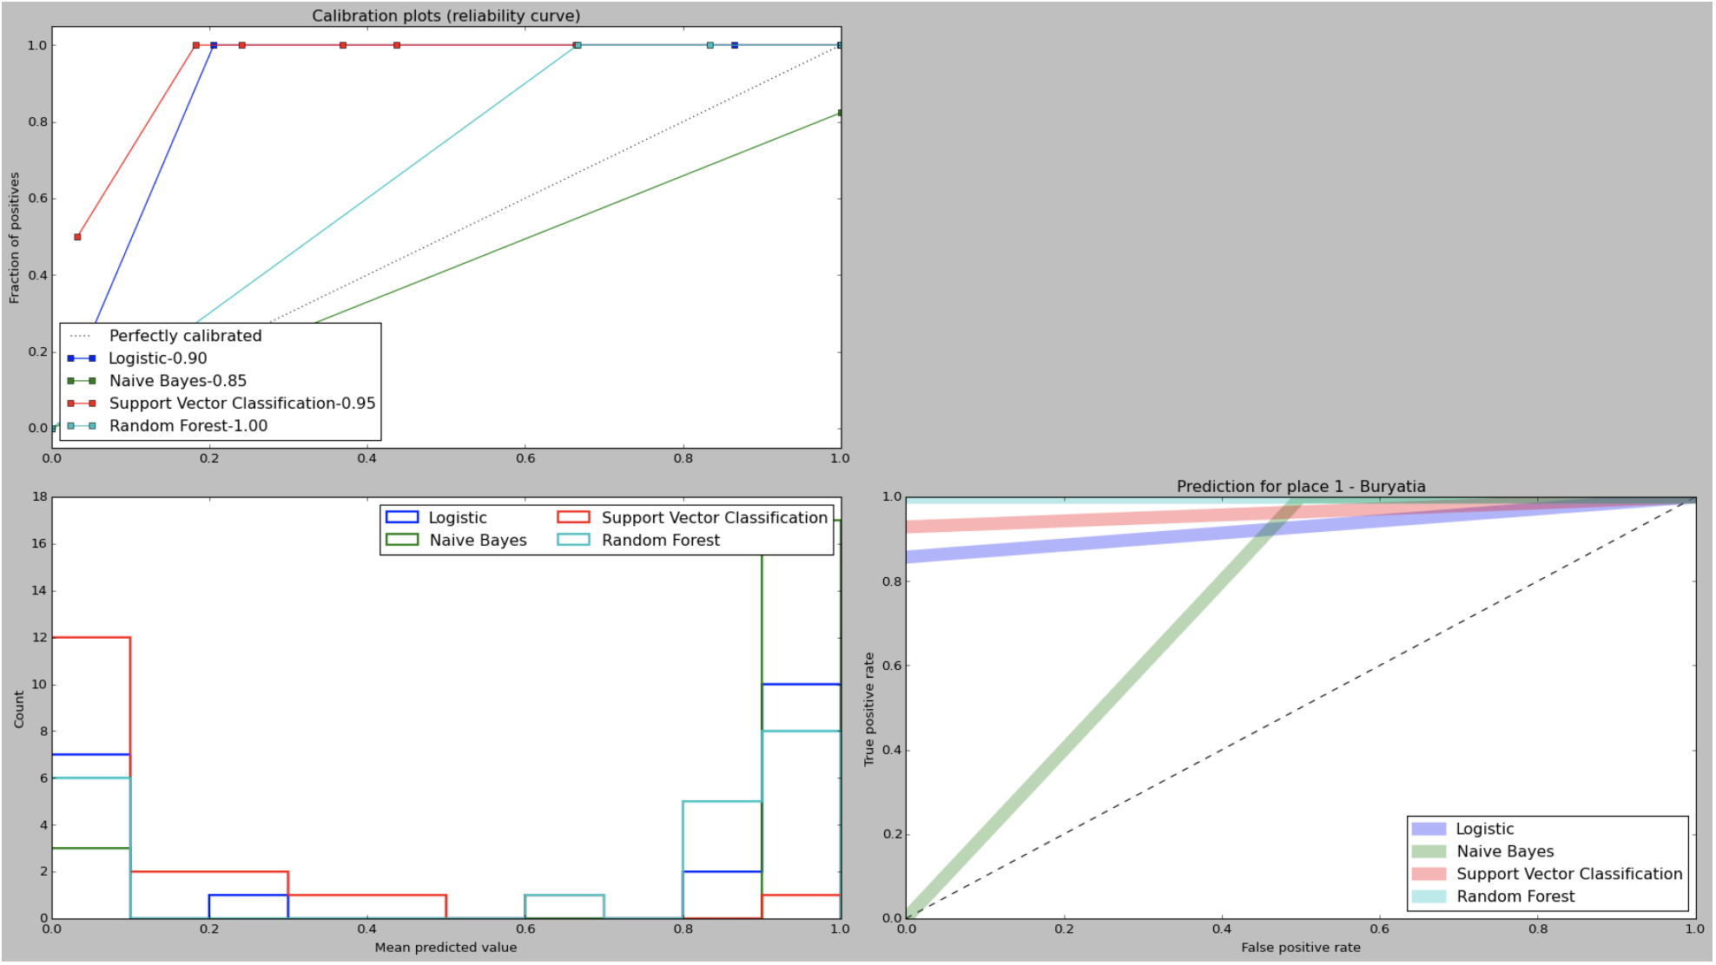

Results were compared among Logistic, Naive Bayes, Support Vector Machine, and Random Forest classifier. Results were generally good, with TPR/FPR being optimized for Random Forest with a high recall rate (lower-right diagram). The out-of-sample prediction values were listed for 10 days. The predicted values are largely similar between Random Forest and Naive Bayes (lower-left). Finally the calibration plots indicate Random Forest has the best reliability with (1.00) value (upper-left).

Prediction Example - Siberia
Using Siberia as a test region (region #2) we predict a 10-day sequence of protest incidents:

9/12/2019 9/22/2019
Y_pred (random forest) [0. 0. 0. 0. 1. 0. 1. 0. 0. 0.]
Y_pred (actual) [0. 0. 0. 0. 1. 0. 1. 0. 0. 0.]

10-day protest activity is perfectly predicted for territory #2 (Siberia) using each day’s input of tweet activity from all territories.

Number of protest tweets (including retweets) by day and territory:
Day (1-10)
|
V Territory ->
[[ 4. 51. 0. 1. 0. 0. 0. 0. 0. 0. 1. 0. 0. 7. 0.]
[10. 77. 0. 0. 0. 0. 16. 0. 0. 0. 0. 0. 0. 5. 0.]
[ 7. 12. 0. 0. 0. 0. 0. 0. 0. 0. 0. 0. 0. 2. 0.]
[ 1. 3. 0. 0. 0. 0. 0. 0. 0. 0. 0. 0. 0. 0. 0.]
[ 0. 3. 0. 0. 0. 0. 0. 0. 0. 0. 0. 0. 0. 0. 0.]
[23. 5. 1. 0. 0. 0. 1. 0. 0. 0. 0. 0. 0. 0. 0.]
[ 3. 5. 0. 0. 0. 0. 0. 0. 0. 0. 0. 0. 0. 0. 0.]
[ 9. 15. 1. 0. 0. 0. 1. 0. 0. 0. 0. 0. 0. 0. 0.]
[11. 33. 0. 0. 2. 0. 0. 0. 0. 0. 0. 0. 0. 0. 0.]
[ 5. 28. 0. 6. 1. 0. 0. 0. 0. 0. 0. 0. 0. 0. 0.]]

Below is the ML diagram for the Siberia prediction case. We still see that Random Forest is able to isolate and predict the best of the algorithms.
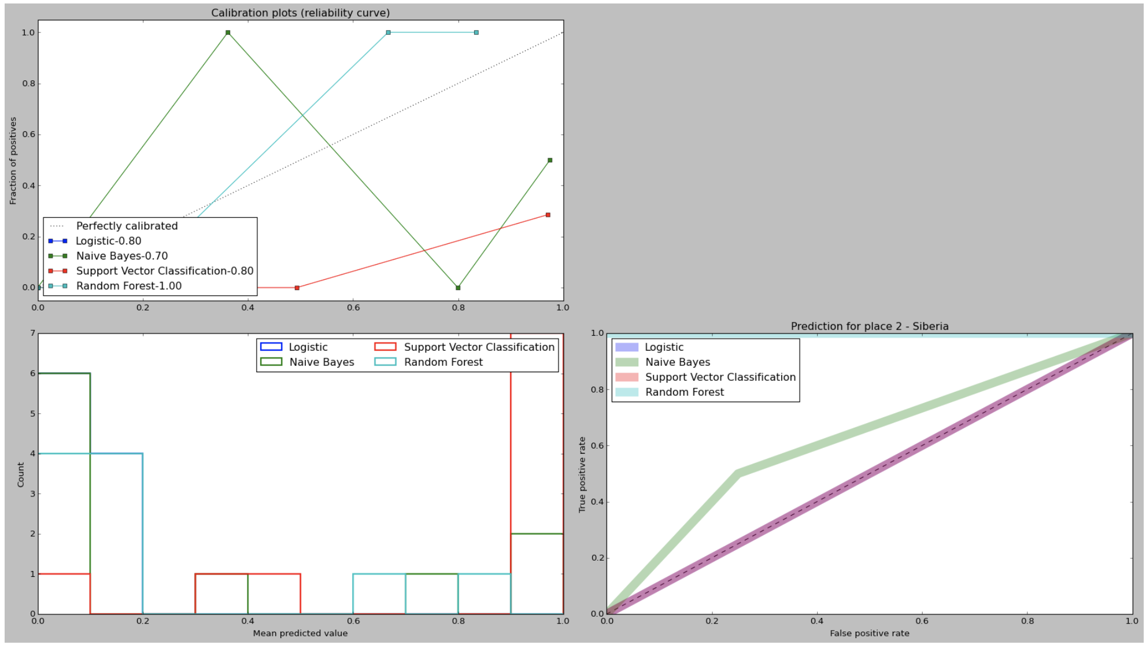

A leaf attribution from a random forest in our model can show how each location’s tweet counts can be combined together to form an overall ‘y’ protest existence for a given location.

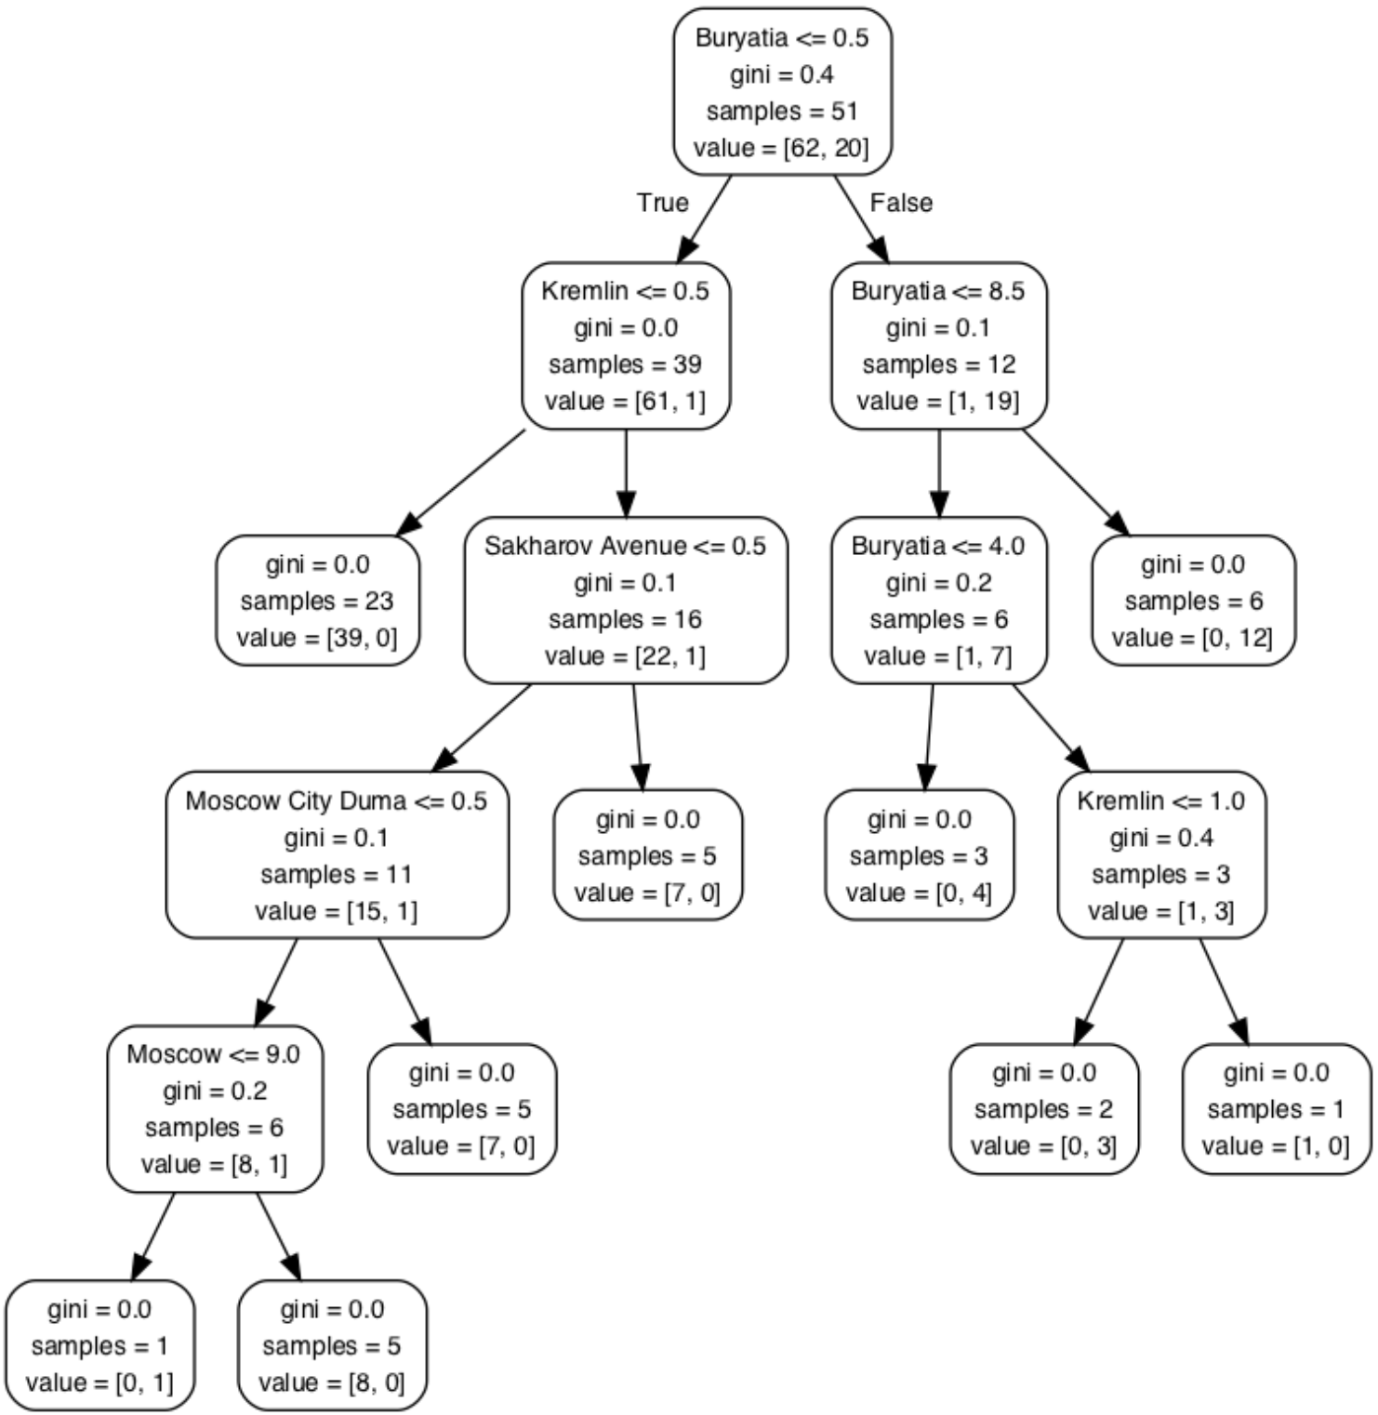

The right-hand side of the tree suggests that a protest in Buryatia may only lead to protest in Buryatia, whereas the left hand side suggests tweets in Buryatia/Kremlin would lead to a protest incident in Kremlin/Moscow. The decision tree is dictated by the gini splitting coefficient, as well whether there are Kremlin protests or not. This can provide some additional interpretation of the structure behind the various territories and how their tweet traffic can affect each other.

